1. Animal Trading Cards Overview

Design prototype to an actual website. Swap the fish out for the animal of my choice.

1. Download the files
2. Replace the animal with my favorite, the Pangolin! Link to responsive images is broken, but basically how to scale web graphics without distorting them.
3. Add proper CSS to styles.css and recreate the design prototype.
4. Follow the guidelines:

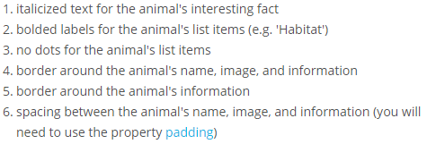

1. Animal Trading Cards

